 |  | February & March 2020 |  |  | Welcome  Welcome to our January & February edition of our activites schedule for the Macmillan Horizon Centre.  We offer a wide variety of activities to help support you and our programme is updated all the time.  If you’d like to book onto any of our services please call 01273 468770  If you have a Facebook account, you can like and follow our page for the latest information on classes, groups and activities that you can join here at the Horizon Centre. www.facebook.com/macmillanhorizoncentre
 | 01273 468 770
 | horizoncentre@macmillan.org.uk
 | www.macmillan.org.uk/horizoncentre
 | 2 Bristol Gate, Brighton, BN2 5BD


Reiki is Japanese in origin and when translated into English, it means ‘universal energy’. Reiki is based on the concept that there is a flow of energy which exists within living beings, which may help to maintain balance. During the Reiki treatment, the therapist places their hands on or just above different parts of the body, which helps to relax the body and calm the mind.

We have recently welcomed two new Reiki therapists to the Centre and if you would like to book in for a treatment please call us on 01273 468 770 or email horizoncentre@macmillan.org.uk



JSJ is an Ancient Japanese Art of harmonising the energy within
the body. It is a subtle, yet powerful form of acupressure/
acupuncture without the use of needles or pressure. The therapist
gently places hands on specific points on your clothed body (it’s not a massage but it feels like one). The experience is both energising
and deeply relaxing.
As the core of JSJ is self-help, the therapist will provide you with
some very simple exercises, to help prolong the healing effects of
the therapy.
If you would like to book in for a treatment please call us on 01273 468 770 or email horizoncentre@macmillan.org.uk

RESTORE aims to support people living with cancer related fatigue. It provides information about things you can do to help you cope with fatigue. It can also give you more confidence to manage your fatigue.
RESTORE has been designed by the University of Southampton in collaboration with Macmillan Cancer Support and is based on the most up-to-date evidence.
For further information and to access services of RESTORE use the following link:
https://www.macmillanrestore.org.uk/

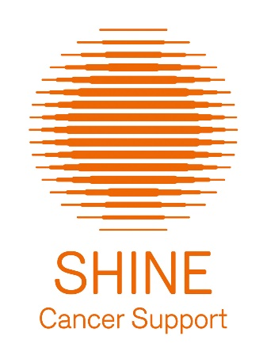
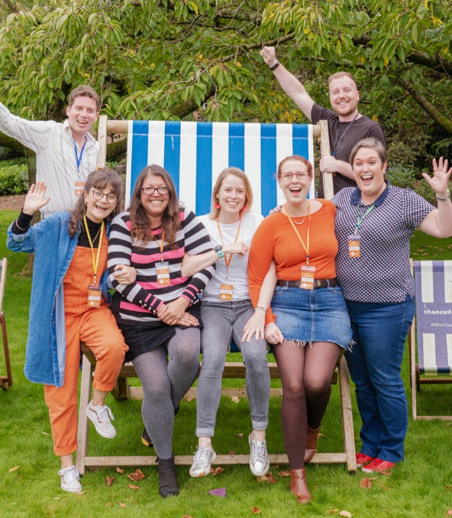
Shine Cancer Support (reg. charity no 1146902) is the only charity in the United Kingdom that is exclusively focused on supporting men and women in their 20s, 30s and 40s who have had a cancer diagnosis.

Our vision is that every adult in the UK diagnosed with cancer in their 20s, 30s or 40s can access the help and support that they need in a way that suits their lifestyle, and that they are a part of a confident, supportive, and empowered community of young adults with cancer.

For more information:
Email hi@shinecancersupport.org
www.shinecancersupport.org
https://www.facebook.com/ShineCancerSupport/
https://twitter.com/shinecancersupp
https://www.instagram.com/shinecancersupport/




Paula our expert volunteer Heart Practice Yoga teacher will be bringing gentle movement and plenty of chances to rest and restore, a chance to take time out for you.
Dates and have now been confirmed. If you have registered your interest, we will be in touch in the coming weeks. Demand has been high so we may not be able to accommodate all interested parties, but we will retain your details for the next sessions.


Living with Pancreatc Cancer Support Day
Amex Stadium - 27/02/2020 10:00-14:00
A supportive and informative day for people living with pancreatic cancer.
This free event includes refreshments and talks about various aspectics of
pancreatice cancer, including managing your diet and symptoms as as well as
information about the services we provide for people with pancreatic cancer
and their families.
There will also be plenty of opportunities to discuss any particuar concerns
with one of our nurse specialists.
For more information and to book onto the day please visit:
https://www.pancreaticcancer.org.uk/information-and-support/support-for-you/living-with-pancreatic-cancer-support-days/forthcoming-living-with-pancreatic-cancer-support-days/2020/february/brighton-living-with-pancreatic-cancer-support-day/

We can offer haircuts, headshaves and styling through our programme of complementary therapies. Ask at reception for more information and to book a 1-2-1 appointment.

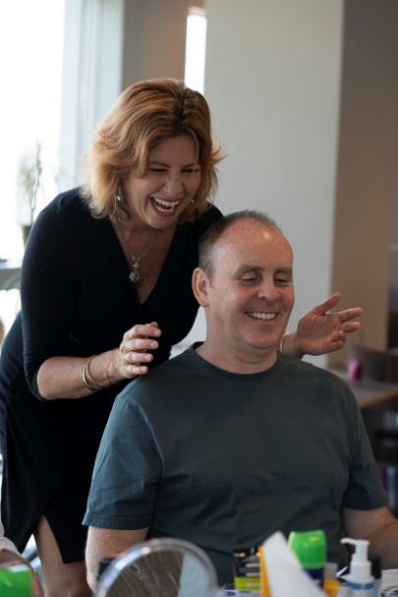


Our “Skin Fitness” Programme is facilitated by our Look Good Feel Better Partners. The session is between an hour and a half to two hours and covers skincare, shaving, grooming, sun protection, advice on scarring and help with eyebrows/skin cover-up if required.

Each attendee receives a gift bag which contains the following products:
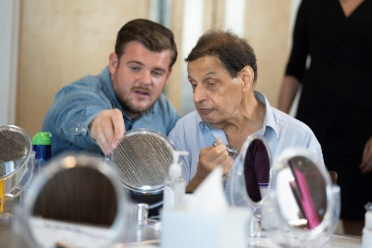
- Face wash
- Face scrub
- Aftershave balm
- Moisturiser
- Face SPF
- Body SPF
- Lip balm
- Body wash
- Fragrance

Courses will be held in 2020 so If you’d like to register your interest for this session please do give us a call on 01273 468 770 alternatively you can email us on horizoncentre@macmillan.org.uk

Further information around the services led by our partner can be found here:
https://www.lookgoodfeelbetter.co.uk/support-advice/men/#men_form

    If you’d like to speak to one of the teams experts give them a call on:  01273 778516 |  |  | 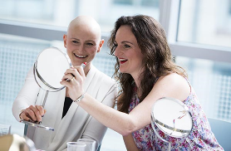  No matter what stage of hair loss you may be experiencing, Trendco is here to help.  We offer a group session about hair loss before, during and after your cancer treatment which includes:  - Ready to wear samples of wigs and other headwear  - Brochures of styles and colour samples  - Information on what your NHS wig prescription provide  All welcome to drop-in at any time during the day.

Social workshop for anyone who would like to learn different headscarf tying techniques & receive advice on all aspects of headwear.

There will be a huge selection of ready-tied headscarves, turbans, beanies & hats in a variety of colours prints to try on!

You can also bring your own and learn how to tie and fix them.www.chemoheadwear.co.uk for more information



Our complementary therapy service is facilitated by our volunteer therapists who so willingly donate their time to the Macmillan Horizon Centre and our clients.

The demand for a complementary appointment is high so please do bear with us as there is currently a 4-5 week wait for appointments, that said we are continuing to recruit new complementary therapists to increase our capacity and we continually strive to accommodate the needs of our clients and we thank you for your patience.

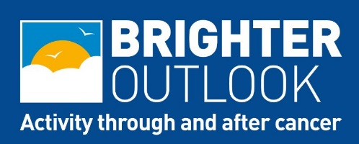
Check out the website for more information www.brighteroutlook.org.uk email brighteroutlook@albioninthecommunity.org.uk or call the team on 01273 668591.

Move More Sussex - if you live outside of Brighton and would welcome some support in getting active, the coaches at Albion in the Community, via Move More Sussex, offer free advice, support and signposting to groups and classes across the county and at the Horizon Centre. Call 01273 668591 or email movemore@albioninthecommunity.org.uk

Walk Tall Football
If you’d like to join a fun and friendly class based on gentle exercise and football skills, this group is for you. Run by our friends at Albion in the Community as part of Brighter Outlook at King Alfred Centre in Hove, 1-2pm on Mondays from 2nd September. Call 01273 668591 to book direct.

Look Good Feel Better – Make-Over Sessions

These popular sessions are open to all women with a cancer diagnosis from point of diagnosis, up to a year after treatment has been completed. Each woman is given a gorgeous Look Good Feel Better gift bag of full-size skincare and make-up products from a variety of High Street cosmetic brands that support the charity.

Get in touch to book your space on sessions now; 10/02, 25/02 and 31/03.

For information on the sessions in Chichester at St Richard's Hospital, please call 01243 831727.

The next free sessions in Worthing are at Worthing Hospital. To enquire about availability and make a booking here, please call 01903 285132.

For other sessions in Sussex please follow the link: www.lgfb.co.uk
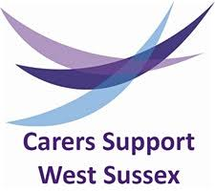
Do you look after someone who could not manage without your help?

Support and information is available for anyone looking after someone who could not
manage without help.


Drop-in sessions are available at the Centre:
- Carers Support 2nd Tuesday of every month 10am to 12 noon
- Carers Hub last Thursday of every month 1.30pm to 3.30pm.
  A chance to use your breath to help you relax and feel calmer.    The group is suitable for most people, although if you have lung disease or shortness of breath you may wish to discuss your needs prior to signing up |  |  |  |     Our popular Mindfulness sessions run on the first Friday of the month 1.30 – 2.30pm, check our dates for your diary page for the next session.  Whether Mindfulness is completely new to you or you’re an experienced meditator, you’re welcome to come and enjoy this tranquil hour.  There’s no need to book ahead, we just ask that you arrive to start at 1.30pm.

We’re taking names of people interested in attending our next three-part cookery workshop series.

These popular workshops are themed as follows:
- Breakfast boost - learn how to make granola, ways to cook eggs, breakfast smoothies and lots more.
- Eat a Rainbow - a chance to learn how to make soups, salads, dips and other delicious dishes.
- Protein Positive - looking at sources of healthy protein, concentrating on alternatives to red meat.
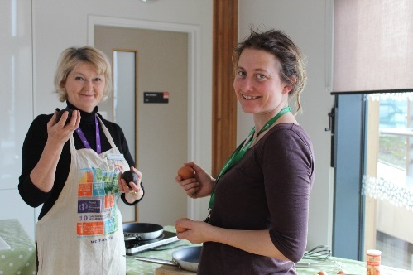
Mhairi and Emma, pictured, are your course experts who will have you kitchen confident in no time. You can sign up for more information, either at reception or by emailing ewinder@macmillan.org.uk
In addition to these scheduled activities we provide:
- an information drop-in service
- counselling and psychological therapies
- a friendly cafe
- welfare benefits and money advice
- Our Sanctuary Light & Sound Room


February | March
05 - Pilates 13:30-14:30 (3of8 - call to book a place)  06 – BRCA Brighton Support Group for Women Across Sussex 18.30-20.45  07 – Mindful Hour 13.30-14.30  10 – Look Good Feel Better 10-12 (call to book a space)  10 – Sisters Abreast – Breast Cancer Support Group for Women under 45  11 – LGBTQ+ Urology Cancer Support Group 17:00-18:30  11 – Carers Support drop in session 10.00-12.00  12 - Pilates 13:30-14:30 (4of8 - call to book a place)  13 – Bright Sparks Brain Tumour Support Group 18.30-20.30  14 - Chemoheadwear Workshop 10:30-12:30 (call to book a place)  17 – CBAS Hot Flush Group 15.45 – 17.00 (call to book a place)  17 – Breast Cancer Support Group 18.30-20.30  19 - Pilates 13:30-14:30 (5of8 - call to book a place)  21 – THANCS Head and Neck Support Group 16.00-18.00  25 - Look Good Feel Better 10-12 (call to book a space)  25 – TRENDCO 10.00-15.00 Drop in  26 - Pilates 13:30-14:30 (6of8 - call to book a place)  27 – Pancreatic Cancer UK Support Day 10.00-14.00, Amex Stadium (book via their website)  27 – Carers Hub drop in session 13:30-15:30 | 04 - Pilates 13:30-14:30 (7of8 - call to book a place)  05 – Qigong 13:30-16:30 (call to book a place)  05 - BRCA Brighton Support Group 18:30-20:45  06 - Mindful Hour 13.30-14.30  09 - Sisters Abreast Support Group 18:30-20:00  10 - Carers Support drop in session 10.00-12.00  10 - LGBTQ+ Urology Cancer Support Group 17:00-18:30  11 - Pilates 13:30-14:30 (8of8 - call to book a place)  11 - Beat Bladder Cancer Together Support Group 18:45-20:00  11 – PcaSO Prostate Cancer Support Group 19:00-21:00  12 - Qigong 13:30-16:30 (call to book a place)  12 - Bright Sparks Brain Tumour Support Group 18:30-20:30  16 - CBAS Hot Flush Group 15.45 – 17.00 (call to book a place)  16 - Breast Cancer Support Group 18:30-20:30  18 - Chronic Myeloid Leukaemia Support Group 18:00-19:00  18 - Leukaemia Support Group 19:00-21:00  19 - Qigong 13:30-16:30 (call to book a place)  19 - Lymphoedema Support group 19:00-21:00  20 - Chemoheadwear Workshop 13:00-15:00 (call to book a place)  26 – Carers Hub drop in session 13:30-15:30  26 - Qigong 13:30-16:30 (call to book a place)  31 - Look Good Feel Better 10-12 (call to book a space)  31 – TRENDCO 10.00-15.00 Drop in

