SOP Title | Genomic Testing for Inherited Breast Cancer
Version
Author
Issued by
Date Issued
Date Updated
Directorate

Introduction
Around 55,000 women and 370 men are diagnosed with breast cancer in the UK each year. Approximately 5-10% of breast cancers are caused by an inherited genetic alteration, BRCA1 or BRCA2 account for the majority of these. Next Generation Sequencing technology has made it possible to sequence multiple genes simultaneously, at lower cost, thus maximising the health benefits to patients with a suspected inherited cause of their breast cancer. Included in the National Genomic Test Directory R208 panel for inherited Breast and Ovarian Cancer are seven genes: BRCA1, BRCA2, PALB2, CHEK2, ATM, RAD51C and RAD51D.
Knowing if a patient has these alterations helps to ensure they are given the most appropriate and effective treatment for them. It can also aid in preventing future cancers, both for the patient and their families. Lifetime risk (until age 80 years) of breast cancer associated with BRCA1 pathogenic variants are estimated to be 65–79% and for BRCA2 pathogenic variants, 61–77%; within this group, the risk of developing a second breast cancer is estimated to be between 40-60%. The lifetime risk of developing breast cancer associated with the other five genes ranges between 11 and 53%. Other cancers associated with the genes in the R208 panel include, male breast cancer, ovarian cancer, prostate cancer and pancreatic cancer; the most significant of which confer a 40-60% lifetime risk of ovarian cancer for BRCA1 pathogenic variant carriers and a 25% lifetime risk of prostate cancer for BRCA2 pathogenic variant carriers (Kuchenbaecker et al, 2017).
Genetic testing of cancer patients and their unaffected relatives facilitates the implementation of risk-reducing strategies and more effective treatment including: targeted therapies, enhanced surveillance, chemoprevention and risk-reducing surgery (bilateral mastectomy and/or bilateral salpingo-oophorectomy). Awareness of pathogenic variants in the R208 gene panel can guide the surgical treatment and appropriateness of adjuvant therapies for those patients considering risk reducing surgery and systemic anti-cancer therapy (SACT).
This SOP is designed to guide appropriately trained doctors and Clinical Nurse Specialists to undertake counselling and consenting of patients who fall under the mainstreaming criteria for Germline testing as set out in NHS England’s National Genomic Test Directory (2023). This is to ensure all patients receive a safe and effective high-quality service by facilitating patients’ timely access to the most appropriate treatment.

Responsibility
It is the responsibility of the MDT including surgeons, oncologists, nurses and allied healthcare professionals to follow this SOP in accordance with the Trust Escalation Policy and Corporate Strategy.

Team Members | Details
Consultants
Lead Breast Nurse
Clinical Nurse Specialists

BRCA TESTING CRITERIA
The National Genomic Test Directory (NGTD) sets out the test criteria for BRCA testing:
Germline BRCA testing - Testing on blood. All patients who meet the following mainstreaming criteria with breast cancer should be offered germline BRCA testing, which can be performed via a blood sample following the necessary counselling and consent. If the patient does not wish to undergo testing at the time it is offered, they can consent to DNA storage for testing at a later point if desired.
Testing based on Family History - Patients meeting the extended testing criteria for germline BRCA testing as set out in the NGTD may also be tested. This may include patients with additional family history of cancer, particularly those related to the BRCA gene – ovarian, breast and to a lesser extent prostate, pancreatic or melanoma.
Living unaffected individual with:
a. first degree relative affected by breast or serous ovarian cancer, AND
b. Combined pathology-adjusted Manchester score ≥20 or BOADICEA/CanRisk score ≥20% (for the first degree affected relative), or BOADICEA/CanRisk score ≥10% (for the first degree unaffected relative)
AND
c. No living affected individual is available for genetic testing, AND
d. No deceased affected individual with tumour material available for testing

Living affected individual (proband) with breast or ovarian cancer where the individual +/- family history meets one of the criteria. The proband has:
a. Breast cancer (age < 40 years), OR
b. Bilateral breast cancer (age < 50 years), OR
c. Triple negative breast cancer (age < 60 years), OR
d. Male breast cancer (any age), OR
e. Breast cancer (age <45 years) and a first degree relative with breast cancer (age <45 years), OR
f. Combined pathology-adjusted Manchester score ≥15 or single gene pathology adjusted score of ≥10% or BOADICEA/CanRisk score ≥10%, OR
g. Ashkenazi Jewish ancestry and breast cancer at any age

NOTES
•Breast Cancer definition includes high-grade DCIS
The proband's cancer and majority of reported cancers in the family should have been confirmed.
• The pathology adjusted Manchester score involved incorporation of pathology data for the tested proband alone, i.e. pathology need not be sought for other family members.
• Ovarian cancer: Fallopian Tube and Primary Peritoneal cancers can be included.
• BRCA1/BRCA2 testing should not typically have previously been performed. Exceptions include for example, patients who have been tested through the Jewish Community’s NHS BRCA-Testing Programme for BRCA1/BRCA2 and not received a molecular diagnosis.
• Testing of unaffected and deceased individuals can only be offered by Clinical Genetics
Genetic testing may occasionally be appropriate outside these criteria following discussion at a specialist MDT with a cancer geneticist present.

Germline testing pathway

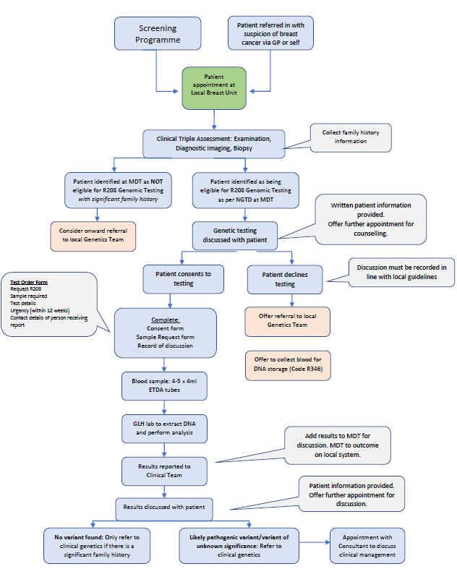

- Germline sample to include 4-5ml EDTA (purple-top tube) total 10-20ml.
- Cancer clinician may include Surgeon, Oncologist, Registrar, Clinical Nurse Specialist etc, who has completed appropriate training on counselling and consenting.

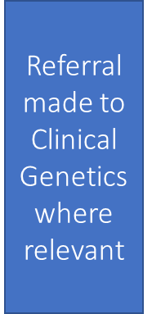

Training to take consent
- Complete additional genomics courses/training depending on the individual Clinical Nurse Specialist’s learning needs. Recommended courses include the following from Genomic Education Programme (available for free for NHS and UK Universities via NHS England’s Elearning for Health portal Online courses Archives - Genomics Education Programme (hee.nhs.uk)):

  - Genomics 101 – Taking and Drawing a Genetic Family History
  - Genomics 101 – Genomics in Healthcare
  - Genomics 101 --Genomics Medicine Service: Introduction to Offering Genomic Tests
  - Genomics 101 - Talking Genomics: Tips and Tools for Communicating

- Obtain copies of patient information leaflets, consent forms and test request forms. These are subject to local Trust Governance and approval.
- Complete local Trust eLearning module “318 Consent ESR eLearning”.
- Spend time shadowing clinician who is competent in consenting for mainstreaming testing then complete consenting under their supervision until deemed competent.
- Optional - shadowing the genetic counsellor via Microsoft Teams platform or clinic.

Key documents:
- Consent form
- Patient results letters: Normal, VUS, Variant found.
- Referral to clinical genetics form
- GMS Test Request Form (Blood sample form)
- Patient information leaflet
- Competency Training Checklist

Competency training and evidence form: facilitating germline genomic testing

Note: This framework has been designed to be a developmental tool to support individuals and organisations, and is not intended to be used as a grading or assessment tool. This form is an optional resource that may be used to demonstrate evidence of competence for use in clinical practice; it may be useful for individual records, appraisals or CPD records. Further information can be found at www.genomicseducation.hee.nhs.uk/consent-a-competency-framework/
Start date: |  | Trainee Name: |  |  |  | Position:
Trainer(s):
Assessed and signed by: |  |  |  | Date:
Competency |  |  |  | Tick | Comments
1 Ensures the process of recording consent for a genomic test follows national and local processes and governance arrangements, and is appropriate for the test being requested
Demonstrates familiarity with the National Genomic Test Directory and adheres to this guidance when offering genomic testing, including the funding model, sample requirements and local requesting pathways.
Understands the national and local processes for changes to consent (i.e. at age 16 with capacity, for additional tests, when a patient changes their mind about having the test).
Demonstrates familiarity with principles of the Human Tissue Act 2004, Data Protection Act 2018 and/or General Data Protection Regulation 2018 as they apply to the use of DNA and genomic data.
Date discussed with trainer: |  |  |  | E-signature/initials of trainer:
2 Demonstrates up-to-date knowledge of the conditions occurring within their specialist area for which genetic or genomic testing may be offered
Understands general genetic concepts, the inheritance and mechanism of disease.
Is able to elicit a family history to assess the risk of one or more conditions.
Understands how conditions may present and the variability of clinical presentations.
Knows the likelihood of the patient’s presenting condition having a genetic basis, versus other possible factors (i.e. behavioural, social, environmental) that may contribute.
Recognises the different implications of somatic versus germline analysis.
Date discussed with trainer: |  |  |  | E-signature/initials of trainer:
3 Assesses where genomic testing is appropriate in the patient’s clinical pathway
Knows why a test may or may not be offered.
Considers ethnic and/or population-specific factors that may influence the type of test being offered.
Is aware of alternative tests to the genomic test being offered, if applicable.
Knows of possible future test options and choices, pending the results.
Date discussed with trainer: |  |  |  | E-signature/initials of trainer:
4 Conveys to patients the purpose and process of the clinical test being offered
Explains the context of the test (diagnostic, predictive or carrier).
Outlines the scope and limitations of the test based on the technology being used.
Explains the possible results and the turn-around time and feedback process for any results.
Describes the potential relevance of the test for that patient/family, including clinical actions that may or may not be taken.
Explains possible unexpected results (incidental findings).
Describes the potential uncertainty of genomic information, and the iterative nature of analysing results
Describes how samples and data may be used, stored and accessed.
Outlines the familial implications of results and the importance of sharing results with relatives.
Understands the Code on Genetic Testing and Insurance.
Date discussed with trainer: |  |  |  | E-signature/initials of trainer:
5 Explains and answers questions relating to the National Genomic Research Library* where applicable
Outlines the potential benefits and risks of data and sample use, storage and sharing on personal, familial and societal levels.
Describes how samples and data may be used, stored and accessed.
Explains the process of partial or complete withdrawal of consent for research at any time.
Date discussed with trainer: |  |  |  | E-signature/initials of trainer:
6 Applies core clinical skills to the genomic test conversation
Assesses capacity according to the Mental Capacity Act 2005 and other guidelines (such as Gillick competency).
Establishes the patient’s understanding and expectations of the genomic test being offered.
Employs effective communication skills to support decision making and enable patients to make a choice without coercion or bias.
Tailors provision of information based on the patient’s cognitive ability, age and language.
Engages with all individuals present in the discussion and incorporates the potentially different views of family members.
Addresses the psychosocial impact of genomic testing and risk, taking into consideration the impact of disease on the individual and/or family.
Considers the factors that may influence an individual’s choice to consent, including additional physical and mental health history; cultural, religious, familial and personal values; and timing of the conversation with respect to the patient’s care and/or other life events.
Respects the patient’s right to decline the genomic test, and is able to explain potential implications, limitations, and/or alternatives for the patient’s care.
Date discussed with trainer: |  |  |  | E-signature/initials of trainer:
7 Recognises one’s ongoing responsibilities to the patient and acts when appropriate
Understands that duty of care may extend beyond the initial feedback of genomic findings.
Is able to inform relevant professionals involved in managing the patient’s care and initiate onward referrals to other specialists.
Knows of patient resources, support groups, and eligibility criteria for research (where applicable).
Date discussed with trainer: |  |  |  | E-signature/initials of trainer:
8 Seeks further assistance, where relevant, based on scope of practice
Knows how to contact their local genomics laboratory, Clinical Genetics service and multidisciplinary review meetings if relevant.
Can recognise and understand one’s professional responsibilities and boundaries, and when to refer to relevant specialists for further support or patient management.
Knows how to access educational resources to support learning where relevant (such as Good Clinical Practice training and Genomics Education Programme courses).
Date discussed with trainer: |  |  |  | E-signature/initials of trainer:
Further reflection notes:
e.g. any suggested resources or actions to support competency development, recommendations

Cancer Research UK, 2021.
Catana A, Apostu AP, Antemie RG. “Multi gene panel testing for hereditary breast cancer - is it ready to be used?” Med Pharm Rep. 92, 3 (Jul 2019):220-225. Accessible at: 10.15386/mpr-1083. Epub 2019 Jul 31. PMID: 31460501; PMCID: PMC6709965.
NHS England. National Genomic Test Directory v5 197-198 (London, 2023). Accessible at: https://www.england.nhs.uk/wp-content/uploads/2018/08/rare-and-inherited-disease-eligibility-criteria-v4.pdf.
Ain, Q, Richardson, C., Mutebi, M., George, A., Kemp, Z., Rusby, J. “Does Mainstream BRCA Testing affect surgical decision-making in newly-diagnosed breast cancer patients?” The Breast, 67 (Feb 2023): 30-35. Accessible at: https://www.thebreastonline.com/action/showPdf?pii=S0960-9776%2822%2900193-X
Facing Our Risk of Cancer Empowered. “Cancer Risk for people with inherited mutations”, 2022. Accessible at: https://www.facingourrisk.org/about-us/publications
Kuchenbaecker KB, Hopper JL, Barnes DR et al. ‘Risks of Breast, Ovarian, and Contralateral Breast Cancer for BRCA1 and BRCA2 Mutation Carriers‘. JAMA 2017: volume 317, issue 23, pages 2402-2416. doi: 10.1001/jama.2017.7112
Ain, Q, Richardson, C., Mutebi, M., George, A., Kemp, Z., Rusby, J. “Does Mainstream BRCA Testing affect surgical decision-making in newly-diagnosed breast cancer patients?” The Breast, 67 (Feb 2023): 30-35. Accessible at: https://www.thebreastonline.com/action/showPdf?pii=S0960-9776%2822%2900193-X

