North Mersey Macmillan Project: Urgent Care and Cancer & Cancer Care of the Elderly

Emerging evidence through data analysis and patient engagement

Written by Dr Ernie Marshall (CCC Oncologist and Clinical Lead) and Elliot Graves (Macmillan Project Manager) with support from the Macmillan Project Team
Version 7
Purpose:
Macmillan have funded an 18 month project to provide project infrastructure on a North Mersey footprint* to describe current challenges of managing cancer patients with urgent care needs, with a particular focus on elderly patients, and identify potential solutions to improving the experience of these patients.

*The North Mersey geography includes 3 hospitals which form the basis of this report:
1) Aintree University Hospital (AUHT) – host organisation for the project team
2) Royal Liverpool and Broadgreen Hospitals (RLBUHT)
3) Southport Hospital (S&O)

Contents:
- Data
  - North Mersey Acute Oncology dataset analysis (2011-2015 full set; 2011-2017 for Aintree Hospital)
  - Liverpool GP Out-Of-Hours urgent cancer referrals/direct admissions to A&E (2017)
  - New diagnosis via emergency route (Type 1) patient level audit
  - 24hr A&E Audits x4 (Aintree Hospital)
  - Key themes across data workstreams

- Patient Experience:
  - Acute Oncology patient stories
  - Clatterbridge Cancer Centre (CCC) patient experience survey
  - Liverpool CCG/CCC patient insight work
  - Key themes across patient experience workstreams

- Data
  - North Mersey Acute Oncology dataset analysis (2011-2015 for all NM Trusts; 2011-2017 for AUHT as host organisation)

Purpose: To understand trends and themes in AO activity in North Mersey

Methodology: Access to network Acute Oncology dataset held by tertiary cancer site (CCC). This dataset includes all AO activity as recorded by local hospital AO teams across Cheshire & Merseyside. Quantitative data was reviewed for trends in the number of AO contacts across the 3 North Mersey sites (9355 patients) as well as themes in: patient age; tumour group; palliative status; presentation.

Findings:
North Mersey AO Activity 2011-2017:
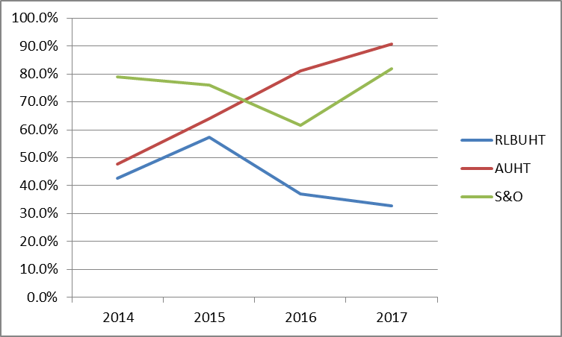

% of AO patients seen by CNS Alone
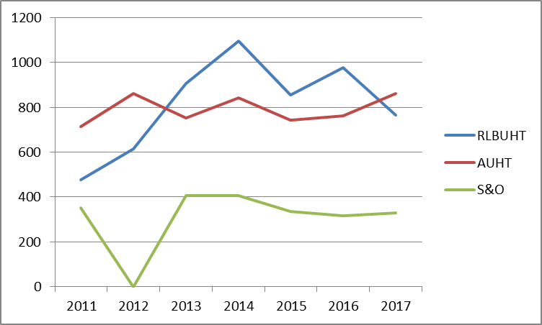

The majority of AO referrals across North Mersey were for patients aged 60+ (71%), with 41% aged 70+. There is some variance between Trusts, with the Southport AO team seeing an older patient cohort than colleagues at AUHT and RLBUHT.

Across all Acute Oncology patient Types, the distribution of primary cancers seen by NM AO teams is split as follows:

Excluding the combined ‘other’; the most common primary cancers for AO referral are Lung; Breast and Urology.
Which tumour groups do NM AO see for Type 1, 2 and 3 referrals?
Other: Haematology, Sarcoma, Skin/melanoma and ‘other’
Other: Haematology, Sarcoma, MUO/CUP/, Primary CNS and ‘other’

Other: Haematology, Sarcoma, Skin/Melanoma MUO/CUP, CNS Primary and ‘other’

What do Type 1, 2 and 3 NM patients present with?

When considering the groups most frequently seen by NM AO teams (Lung; Breast and Urology) there are similarities presentation for both Type 2 and Type 3 patients.
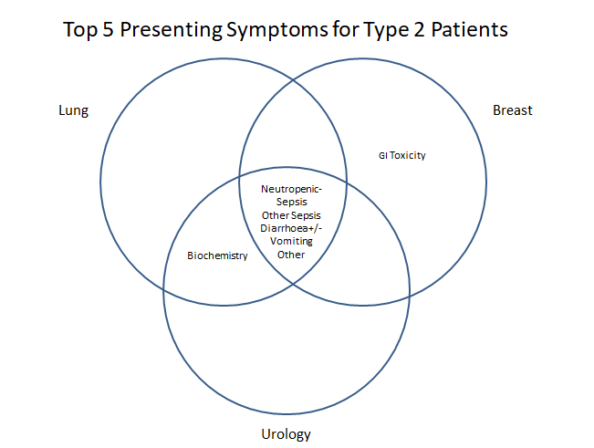
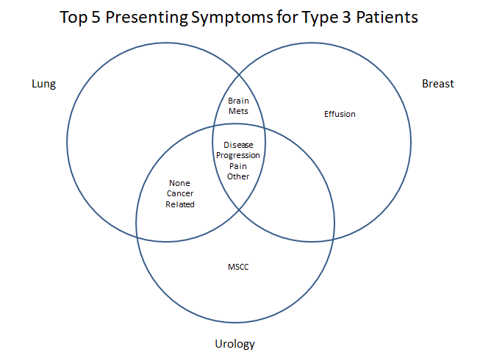

Palliative Status:
Of those patients with a record of palliative status:
92% of Type 1 AO patients were recorded as palliative
60% of Type 2 AO patients were recorded as palliative
88% of Type 3 AO patients were recorded as palliative
AO Weekend Demand
Across the 3 NM Trusts; AO referrals appear low over the weekend, creating a ‘blind spot’ for AO demand during weekend hours.

These referrals are distributed as in Figure 1, with >50% of AO referrals being received on Mon/Tue.
Figure 2 shows a more even distribution of AO A&E presentations throughout the week, with slightly fewer AO patients presenting to A&E on Sat-Sun. The difference between these two figures suggests the increase in referrals on a Mon and Tues represents a ‘back log’ of weekend admissions:
Figure 1 Figure 2
Limitations of AO dataset:
- Data is only available for patients referred to Acute Oncology service, therefore those not referred or discharged before they could be seen are lost
- Information Governance: Depending on local systems and sharing agreements access to AO datasets may be limited for other teams to replicate this work
- Time-lag: regional data is consistently a minimum of 12 months out of date
- Data quality: minimum data-set is not always complete due to lack of available information/time required to manually update Excel spreadsheets

  - Liverpool GP Out-Of-Hours urgent cancer referrals/direct admissions to A&E (2017)
Purpose: To understand themes in circumstances requiring referral to A&E/direct admission for patients Out-Of-Hours

Methodology: PC24 (Liverpool GP Out-Of-Hours provider) provided 12 months’ worth of qualitative data relating to cancer patients who were referred to A&E/for direct admission following out-of-hours GP consultation. Data was analysed for common themes relating to patient age; tumour group; palliative status; presentation; route to Out-Of-Hours GP.

Findings:
The total number of cancer patients referred to secondary care following consultation in 2017 was 206. 98 of these patients were referred to A&E and 108 were referred for direct admission. The origin of the majority of these calls was NHS 111.

The majority of patients referred from consultation to secondary care were 65 and over (68%); with a correlation between increasing age and likelihood of emergency admission:

13% of patients referred to A&E were recorded as palliative.
17% of patients referred directly for admission were recorded as palliative.

The 98 patients referred to A&E presented with the following symptoms:

100% complications of tube/stent/stoma etc.

100% recorded as ‘other’

The 108 patients referred for admission presented with the following symptoms:

100% complications of tube/stent/stoma etc.

100% recorded as ‘other’
1.3 New diagnosis via emergency route (Type 1) patient level audit
Purpose: To define the number of cancer patients diagnosed via an emergency route for Lung; Colorectal; Urology; Brain; CUP and Upper GI cancers.

Methodology: Full Methodology can be found at Appendix 1
  - Generate a “Yearly Diagnosis Report” on Somerset Cancer Register (SCR) and select tumour group.
  - Identify patients diagnosed with cancer via an emergency route by cross checking the patient’s source referral on SCR with their hospital spells on the organisation’s patient notes system. List patients on an Excel database.
  - To ensure no patient has been missed, generate a “Source Referral Report” on SCR for selected tumour group. Filter so only confirmed cancers remain.
  - Cross check this list against the “Yearly Diagnosis Report” and highlight patients who appear on both reports.
  - Identify any un-highlighted patients diagnosed with cancer via an emergency route by cross checking the patient’s source referral on SCR with their hospital spells on the organisation’s patient notes system. Add to Excel database to obtain final figures.

Findings:

Significant disparity across datasets
Cancer Group | Audit findings (% via emergency route) | SCR (% listed as via emergency route) | National Routes to Diagnosis (RTD) Findings | RTD Proxy Measure (HES data lone)
CRC 2017/18 | 21% (42 of 197) | 6.7% (13 of 197) | 24% | 20% (51)
Lung 2018 | 36% (102 of 282) | 5% (14 of 282) | 36% | 36% (103)
Upper GI 2018 | 27% (41 of 154) | 22% (34 of 154) | 35% | 36% (55)
Urology 2017 | 10% (38 of 379) | 1.6% (6 of 379) | 12% | 7% (27)
CUP 2018 | 51% (18 of 35) | 29% (10 of 35) | 64% | Unavailable

SCR Reports:
In comparison with the patient level audit, Somerset Cancer Registry was found to consistently under-report the number of cancers diagnosed via an emergency route.
Investigation of this under-reporting within SCR reports found variable accuracy of coding for ‘referral method’ of different tumour groups:

- 83% of emergency Lung diagnosis in 2018 not coded correctly on SCR
- 66% of emergency Urology diagnosis in 2017 not coded correctly on SCR
- 76% of emergency CRC diagnosis in 2017 not coded correctly on SCR
- 83% of emergency Upper GI diagnosis in 2018 coded correctly on SCR
- 75% of emergency CUP diagnosis in 2017 coded correctly on SCR

Routes To Diagnosis and Routes To Diagnosis proxy measure:
The Routes To Diagnosis Proxy methodology (developed by the National Cancer Intelligence Network and detailed in Appendix X), was followed to decipher the % of the 5 tumour groups explored in this work using Liverpool CCG-help HES data. Findings from this proxy closely matched the National Routes to Diagnosis findings for emergency diagnosis, however both over-reported the number of cancers diagnosed via an emergency route (bar Lung cancer) when compared with 12 months of patient level audit for emergency diagnosis. Analysis of Lung cancers identified within the RTD Proxy method found that, whilst RTD proxy method appears reasonably close to audit figure at face value, identification of Type 1 using SUS data alone was inconsistent:
- 101 Lung emergency diagnosis identified at AUHT via RTD proxy; 102 via patient-level audit
- Only 31 same patients of the RTD proxy patients were found within the ‘true’ audit
- Remaining 72 from RTD proxy were:
  - 13 Type 1 (not recorded on SCR so unknown to audit)
  - 3 Type 2
  - 47 Type 3
  - 9 ‘other’

This presents a complicated picture of defining, recording and reporting diagnosis via an ‘Emergency Route’. This has been further examined in Appendix X, forming the basis of a local case to deliver standardised training on SCR and selection/coding of referral method for emergency presentations of new cancer.

Recommendations:
- Existing data-sets are imperfect, but National Routes To Diagnosis offers an easily accessed tool to demonstrate the a national picture and draw attention to tumour groups that present particularly high incidence of diagnosis via emergency route.
- Agree a definition for ‘Type 1’ diagnosis via emergency route local/regional use by Cancer Managers; MDT co-ordinators/admin staff using SCR and Commissioning/Cancer Alliance colleagues
- A regional standard training package is required for MDT co-ordinator/admin staff to ensure consistency of SCR coding to reflect data on diagnosis via emergency route

1.4 24hr A&E Audits x4 (Aintree Hospital)
Purpose: To determine the ‘size’ of cancer in urgent care, using AUHT as a proxy measure i.e. on average, how many cancer patients present at A&E
Methodology: (full methodology can be found at Appendix X)
1. Obtain list of patients who used urgent care for an agreed audit date via Trust Performance Analyst team. Ensure this covers ALL urgent care (A&E; ED; AMU; paramedics) for both presentations and admissions.
2. Identify cancer patients from the list by cross checking each patient on Trust patient notes system with the Somerset Cancer Register (SCR).
3. Create an Excel database, using the headings in full methodology at Appendix X, and detail for all cancer patients identified.

Findings:
931 patients presented over 4 24hr periods at at Aintree University Hospital A&E in 2018. 49 of these patients had a confirmed cancer diagnosis.
Day | Number of Cancer Patients | Number admitted
Wed 18th July 2018 | 11 | 9
Sat 21st July 2018 | 8 | 7
Wed 17th October 2018 | 16 | 10
Sat 20th October 2018 | 14 | 13
Total | 49 | 34

These 49 patients accounted for 5% of A&E attendances and 18% of admissions across the 4 audit days:

80% of cancer patients were admitted, vs 24% of non-cancer patients:

Which patients present to A&E/ED?

Age Distribution:

69% of cancer patients attending AUHT A&E were aged 60+
53% of cancer patients attending AUHT A&E were ages 70+

Gender
Slightly larger male cohort given a considerably number of prostate cancer presentations in older males

Tumour Group

Patient AO ‘Type’:

*None refers to patients where the presentation was unrelated to their cancer diagnosis

Presenting Symptoms
The top 3 presenting symptoms at A&E were:
Presenting Symptom | Number of Patients
Fall | 7 (14%)
Abdo Pain | 6 (12%)
DIB/SOB | 5 (10%)

  - Key themes across data workstreams
- Cancer patients more likely to be admitted than non-cancer patients
- Unreliable coding for urgent cancer care both within urgent care, and cancer systems/records
- ‘Blind spots’ for AO activity/demand
- Lung; Urology; Breast high risk of urgent care usage
- Age correlated with inc. likelihood of urgent care use and admission
- Significant number of AO patients recorded as palliative
2. Patient Experience

2.1 Acute Oncology patient stories
Aim: To collect patient stories exploring the circumstances leading to emergency presentation/admission.

Method: Questionnaire, information sheet and consent form written for Acute Oncology inpatients. Local acute oncology teams identified suitable patients and gained patient consent to be approached by Macmillan User Involvement (UI) Facilitator. UI facilitator obtained written consent following explanation of patient information sheet and completed questionnaire with patients. This was completed for 5 AO patients (mix of complications of treatment and complications of disease/associated co-morbidities) at each of the North Mersey Hospitals as well as a further 5 lung specific AO patients. Questionnaire, information sheet and consent form can be found at Appendix X.

Findings to date:

Patient 1 (Type 3)
Patient self-presented to AUHT A&E on Friday, after 5 days of pain.
Previous history of sciatica; at time of interview was awaiting pelvic scan, query bone mets
Patient had been given previous advice by their consultant regarding management of the pain and routinely takes steroids and pain relief at home. Patient had attempted to increase their steroid dose to manage the pain but had been unable to cope at home, and their partner was becoming concerned.
The patient had been previously admitted to AUHT via A&E within the last month and was known the AO team, who fast-tracked the MRI referral.
The patient reflected that they were on a ward of palliative care patients, and felt they were “looking at my own outcome”

Patient 2 (Type 3)
Patient rang palliative care nurse at local hospice on Friday after 2 days of back pain. Patient had been trying to manage pain using ibuprofen and a hot water bottle but could no longer cope at home. Nurse advised the patient to call 999 for an ambulance, and the patient was admitted to AUHT via AMU.
The patient reflected that they were on a ward of dementia patients, which they felt was noisy and disruptive

Patient 3 (Type 3)
Patient contacted their GP on Wednesday, unable to walk after 2 days of pain. The GP visited the patient (for the 4th time) and made the decision to admit. The patient reported they had been given previous advise on pain management by their GP (pain relief and use of walking aids), but could no longer manage at home as the pain had become uncontrollable.
The patient had 2 previous admissions in the past 5 weeks, but these were un-related to the current complaint.
When asked what could be improved the patient responsed:
“General attitude of all staff, giving patient information, inclusion in decision making, being given facts and a treatment plan”

Patient 4 (Type 3)
Patient rang a GP friend on Monday after worsening of their dropped foot over the two days of the weekend. The patient had an orthotic for their dropped foot and was under the care of a physio but had experienced a sudden onset of balance loss and feared they might fall. Their friend (GP) advised they call 999 which they did. An ambulance was sent and the patient was taken to Southport A&E. The patient was awaiting a spinal review at the time of interview.

Patient 5 (Type 2)
Bowel cancer patient was contacted by their GP on Tuesday to report findings of their low WBC count. They were directly admitted to Southport via their GP for further investigation. This was the second emergency admission in 1 month for the patient.

Patient 6 (Type 2)
Patient visited their GP on Friday after 2 days of fatigue and pain when passing urine. Patient was prescribed with antibiotics and subsequently called the CCC helpline twice, being advised to increase their fluid consumption. Symptoms continued to worsen and the patient self-presented at Southport A&E. The patient praised their admission process but reflected that they felt their GP could have done more to support with symptoms relief and decision making to have prevented their A&E admission.

Summary:
AO Type | No. of patients
Type 1 | 0
Type 2 | 2
Type 3 | 4

Symptom | No. of patients
Pain | 3
Poor Mobility | 1
Low WBC count | 1
Infection | 1

How long from symptom onset to contacting professional? | No. of patients
Same day | 1
2 days | 4
5 days | 1

Who did you contact? | No. of patients
GP | 4
999 | 1
Hospice Nurse | 1

- All patients reported they could not have managed at home
- 3 Patients had received advice previously on self-management from GP; Oncology Consultant and CCC advice line (2 of which were pain patients, third being query infection)
- 5 of 6 patients were self-managing using fluids, steroids, over the counter pain relief
- 4 of these 5 reported that their self-management wasn't sufficient to control symptoms
- 3 of 6 had had previous admissions in the past 2 months; for one patient this was their 3rd in 5 weeks, having had 4 GP home visits
- 2 of these had previously experienced symptoms before (infection; pain)

2.2 Clatterbridge Cancer Centre (CCC) patient experience survey June 2018
Aim: To gain patient insight from responses relevant to urgent cancer care within CCC patient experience survey (2018).

Methodology: Survey obtained via CCC and reviewed for any responses, data or patient comments relating to urgent cancer care. Survey to be repeated June 2019

Findings:
28% of patients had attended hospital or been admitted as an emergency during their chemotherapy treatment
- 66% with suspected infection
- 40% generally unwell
53% patients presented the same day they started to feel unwell

Method of attendance/admissions:

Following admission, 48% saw a member of the AO team or a clinician involved in their cancer care. Of this 48%:
- 23% saw cancer CNS
- 15% AO nurse
- 10% oncology/haematologist
- 4% palliative care team
- 18% can’t remember

67% of patients did not feel their admission could have been avoided with more or different help at home

General comments from cancer patients regarding their urgent care experience:
- Long waits in A&E; fear of infection
- Long wait for nurse to pick up CCC advice line
- Need to increase awareness of chemotherapy side-effects to A&E staff
- Poor communication from general medical staff and between cancer and general medicine
- “Didn’t see anyone who specialised in cancer”

2.3 Liverpool CCG/CCC patient insight work

Aim: To summarise responses from previous work commissioned by Liverpool CCG/CCC relating to deliver insight into the experiences of patients presenting with query neutropenic sepsis at The Royal Liverpool and Broadgreen Hospital

Methodology: Insight report shared by digital team commissioned to deliver this work.
10 stories were collected (5 from RLH and 5 from CCC) from patients who had developed complications during chemotherapy treatment in 2016/2017.

Findings:
Key areas of importance/significance to patients highlighted within the report:
- Support Networks
- Taking and recording temperature
- Impact on family
- Control of life
- Trust and confidence in medical staff

Insight was summarised into ‘how might we?’ questions, to create a launchpad for further discussion:
- How might we find ways to communicate effectively the reason why it is important to take your temperature every day when receiving chemotherapy treatment?
- How might we support patients to ensure that they do take their temperature every day?
- How might we find ways to explore in which health/self-care technology could support patients when being admitted to hospital?
- How might we find ways to support a family wide approach to self-care?
- How might we find ways for patients to use technology to support other patients with self-care?
- How might we find ways to better communicate to GPs the signs and symptoms of Neutropenic Sepsis?
- How might we find ways to support and replicate best practice services in hospital departments?

2.6 Key themes across patient experience workstreams

Appendices to attach
Type 1 Data How To Guide
24hr A&E audit How To Guide
RTD proxy
Emergency Diagnosis Classification
Patient experience questionnaire; info sheet; consent form

