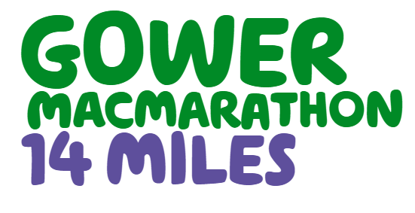
Please return to:
Hiking Challenge Events
Macmillan Cancer Support
89 Albert Embankment
London
SE1 7UQ
Or email to hiking@macmillan.org.uk

Challenge Start Date/Year: 14th September 2019
- Personal Details

Title: | First Name: | Surname:
Date of Birth:
Full Postal Address:

Contact Number:
Email:
T-shirt size: small medium large x-large xx-large

Next of Kin/Emergency Contact:
First Name: Surname:
This should not be someone who will be on the challenge with you
Relationship to you:
Address: Postcode:
Contact Number:

We’ll use your details to fulfil your request.
We may contact you again by post or phone to tell you more about our services and other ways you can help, including opportunities to donate, volunteer or fundraise.
Please let us know if you’re also happy to hear from us by email and text.
□ Yes I’d like to hear from you by email
□ Yes I’d like to hear from you by text
We promise to keep your details safe and never sell or swap them with anyone. If you change your mind about hearing from us, you can stop receiving our updates at any time by emailing contact@macmillan.org.uk or calling 0300 1000 200. Please see our privacy policy for more information at www.macmillan.org.uk [10015]
Gower MacMarathon, 14 September 2019 - Terms and Conditions of Entry
This event is organised by the Swansea Committee [on behalf of Macmillan Cancer Support].

- For this challenge we require a registration fee of £20 (non-refundable) which must be paid at the point of registration. In addition, you pledge to raise a minimum of £125 in sponsorship money for Macmillan Cancer Support which should be received by Macmillan Cancer Support within one month of the Challenge. All funds raised through the Challenge must be payable to Macmillan Cancer Support in £ sterling.

Medical Conditions
If you have suffered/are suffering from any medical condition (for example a heart condition, epilepsy) or are concerned about your health and fitness level, please seek advice from your General Practitioner and provide us with a doctor’s certificate before taking part in the event.

By agreeing to the Terms and Conditions below, I acknowledge and agree to the following:
- I am at least 18 years of age (However, teenagers aged 14 and over can take part if they are accompanied by an adult and a parental consent form is completed. They will still need to pay the £20 registration fee and pledge to meet the minimum fundraising amount of £125).
- I pledge to raise at least £125 for Macmillan Cancer Support.
- If I am no longer able to take part in the event but have raised sponsorship money – this should be forwarded to Macmillan Cancer Support.
- I take part in this event at my own risk and understand the nature of the activity and the risks involved including possible injury to myself and/or damage to my property. It is my responsibility to ensure that I am insured if necessary and sufficiently fit to take part in this event and if I am in any doubt about this I will seek advice from my own General Practitioner before taking part in the event.

- I release Macmillan Cancer Support, its employees and volunteers from any liability for personal injury, death, loss, property, claim or damage suffered by me or any other person during or as a result of my participation in the event unless Macmillan Cancer Support, its employees or volunteers have caused the injury, death, loss, claim or damage as a result of their negligence.

- I have given Macmillan certain information, including medical information, about me and I consent to Macmillan using this data. I understand that it will be necessary for Macmillan to share the data with the Swansea committee and the medical staff in order to organise this event.

Data protection
- We do not sell or swap your details with any third parties, but in order to carry out our work we may need to pass your details to service companies authorised to act on our behalf.
- All participants who choose to attend the event confirm that they are happy for their names, video footage, and photographs taken of them during the event to be used to publicise the event by Macmillan Cancer Support and its trading companies (Macmillan Cancer Support Trading Ltd and Macmillan Cancer Support Sales Ltd) for commercial and fundraising purposes including, but not limited to marketing material, social media, advertising, publications, and other documents or mediums that may be made available to the public. Photographs of children will not be used in this manner without express written consent; unless the images are incidental, for example, children’s images at the starting line. For further information about how we collect and use personal data, please refer to our Privacy Policy.

